**S3 website Hosting Assignment**

**Problem Statement:**

**You work for XYZ Corporation. Their application requires a storage service that**

**can store files and publicly share them if required. Implement S3 for the same.**

**Tasks To Be Performed:**

**1. Use the created bucket in the previous task to host static websites, upload**

**an index.html file and error.html page.**

**2. Add a lifecycle rule for the bucket:**

**a. Transition from Standard to Standard-IA in 60 days**

**b. Expiration in 200 days**

1. Use the created bucket in the previous task to host static websites, upload

an index.html file and error.html page**.**

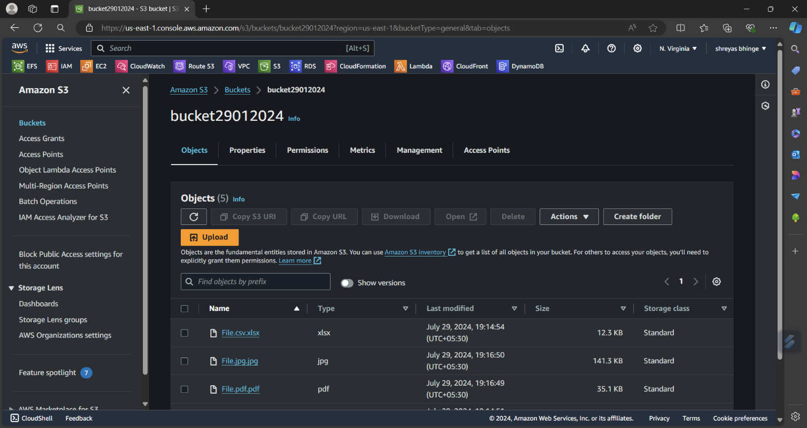

Uploaded Index.html and erorr.html page

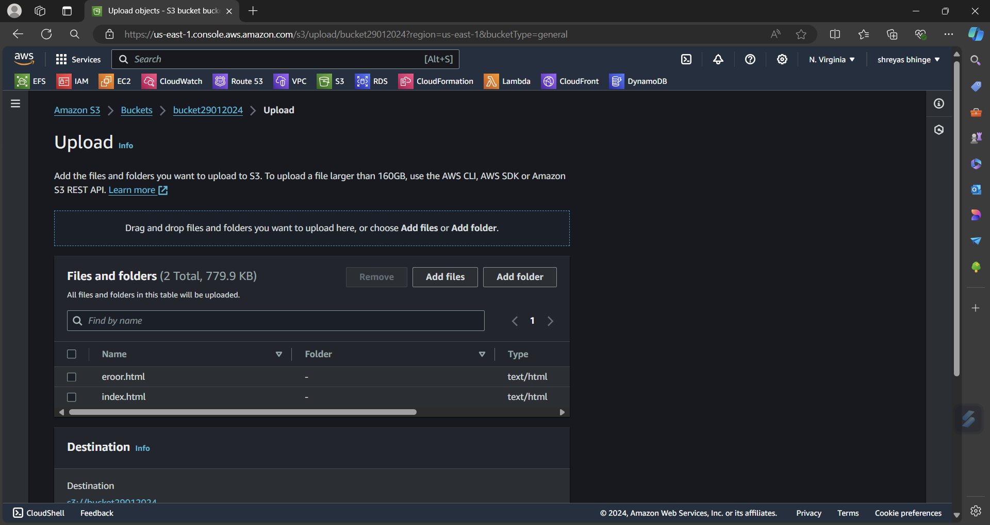

Allowed Public Access

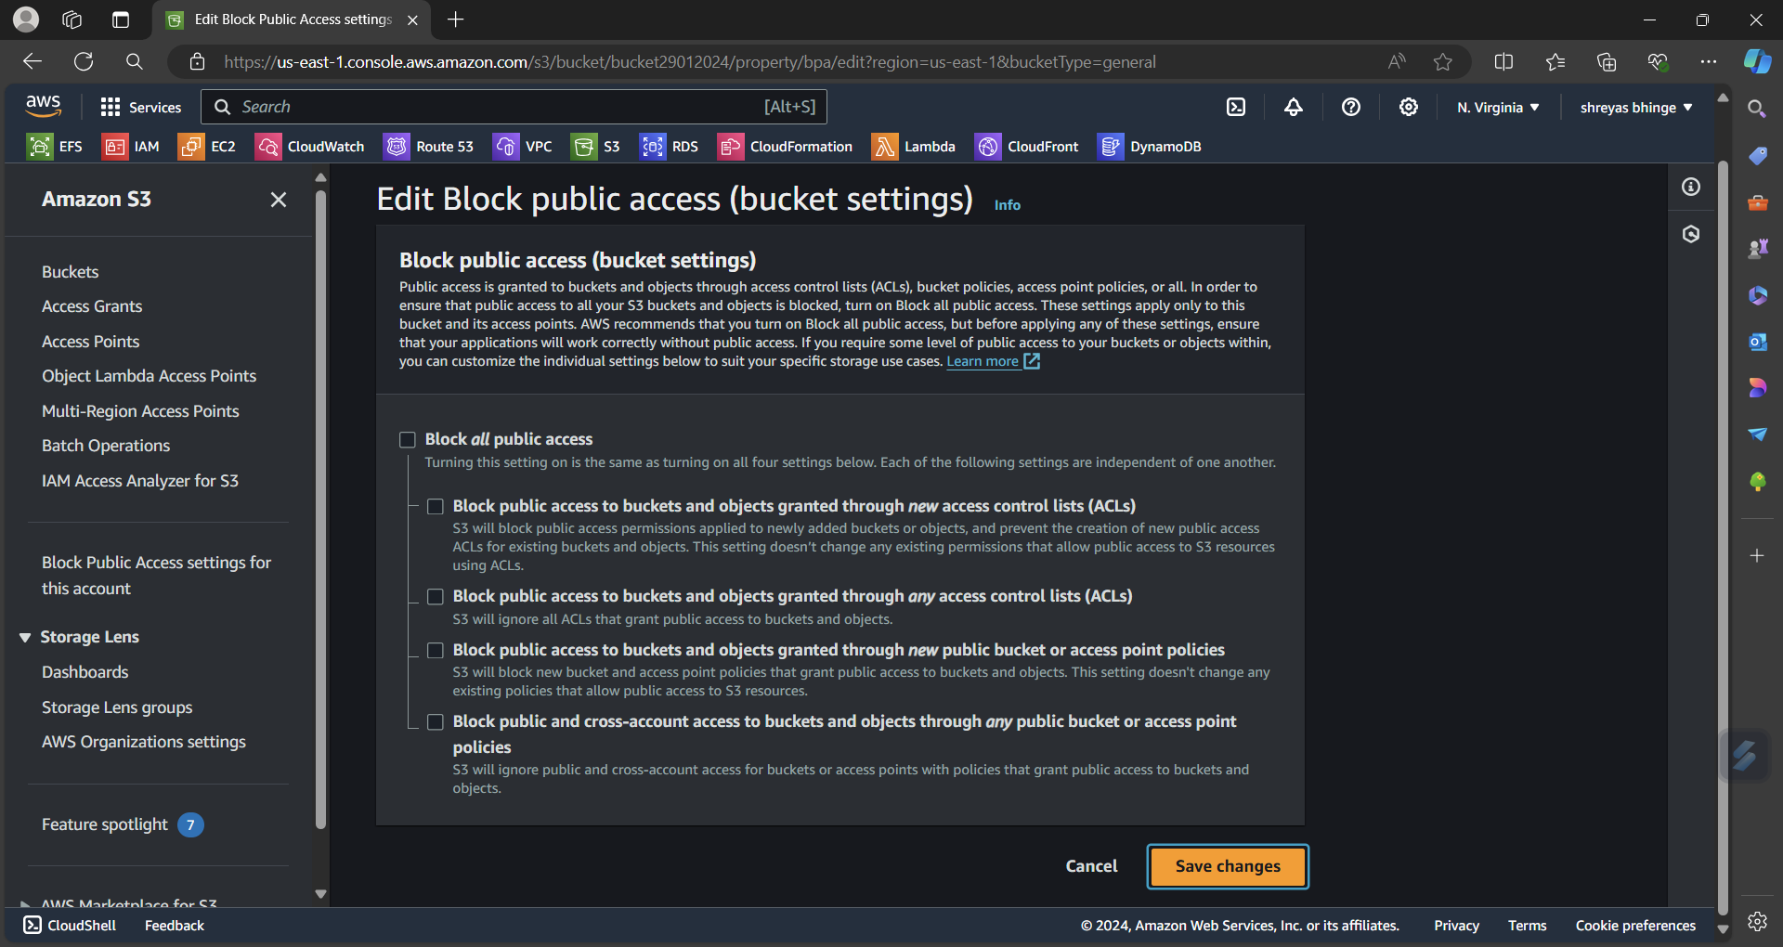

Edit Bucket Policy to Get Object

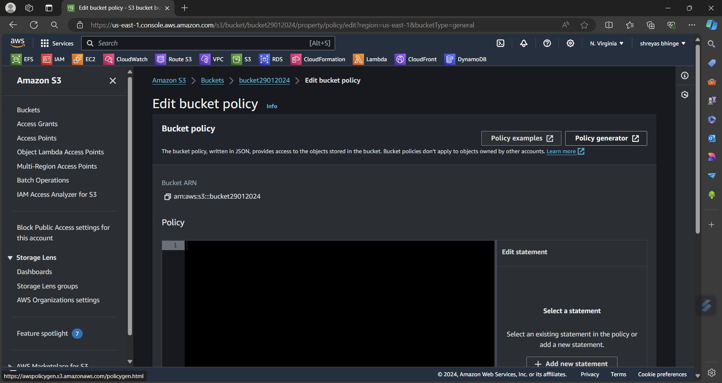

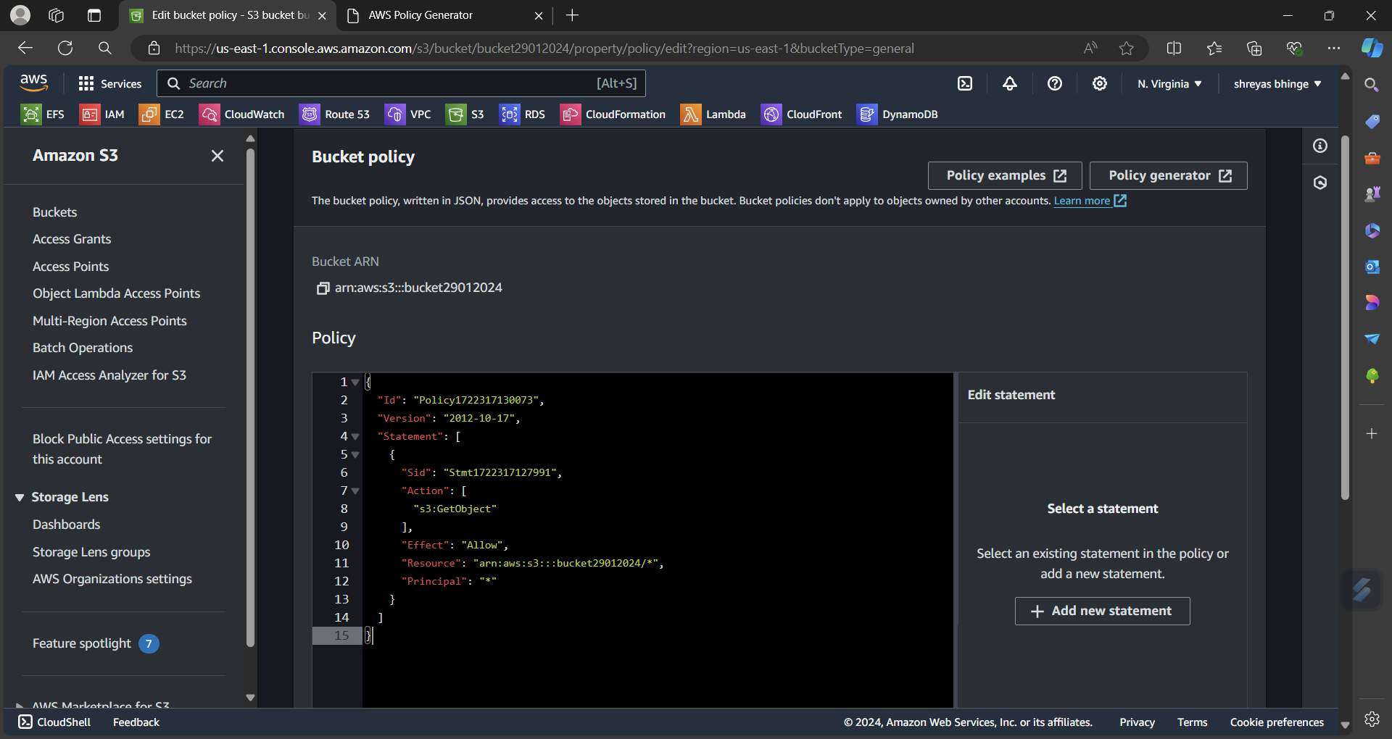

Enable static website hosting

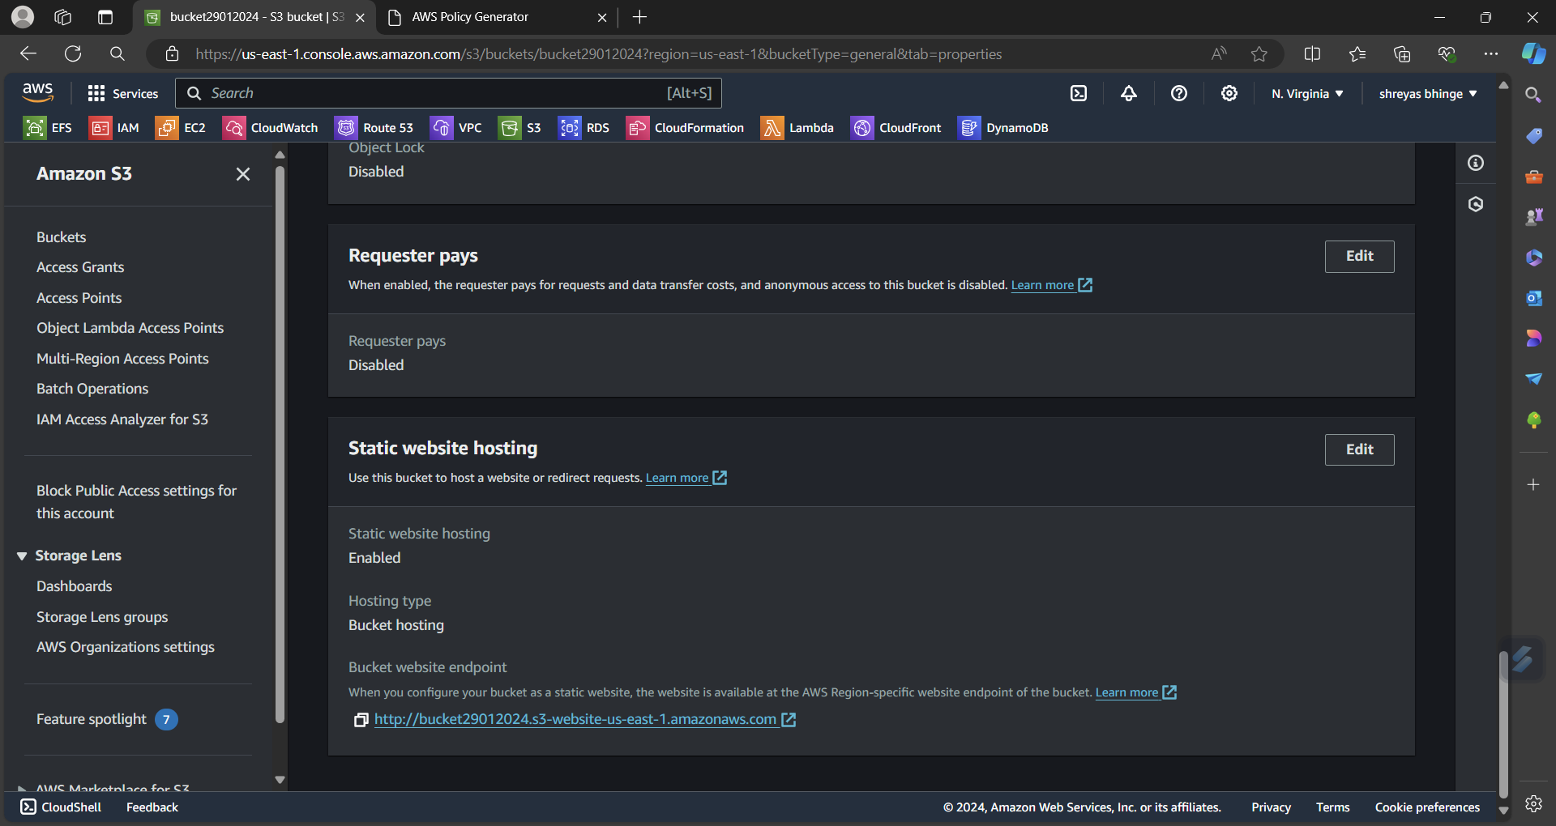

Cope url

index page

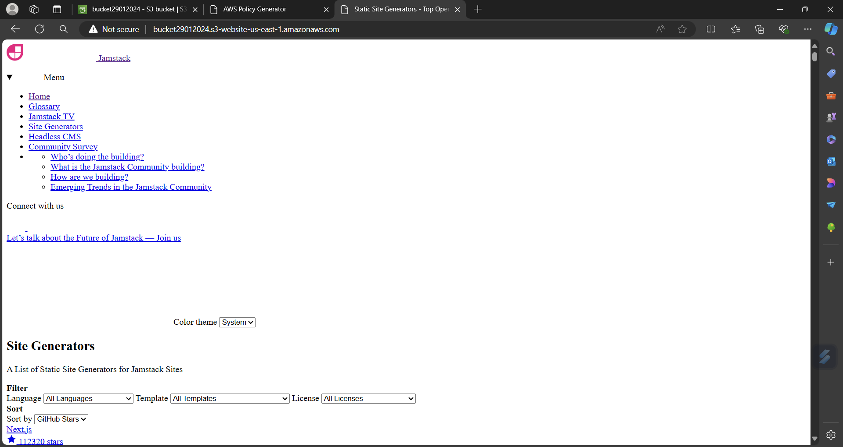

Error page

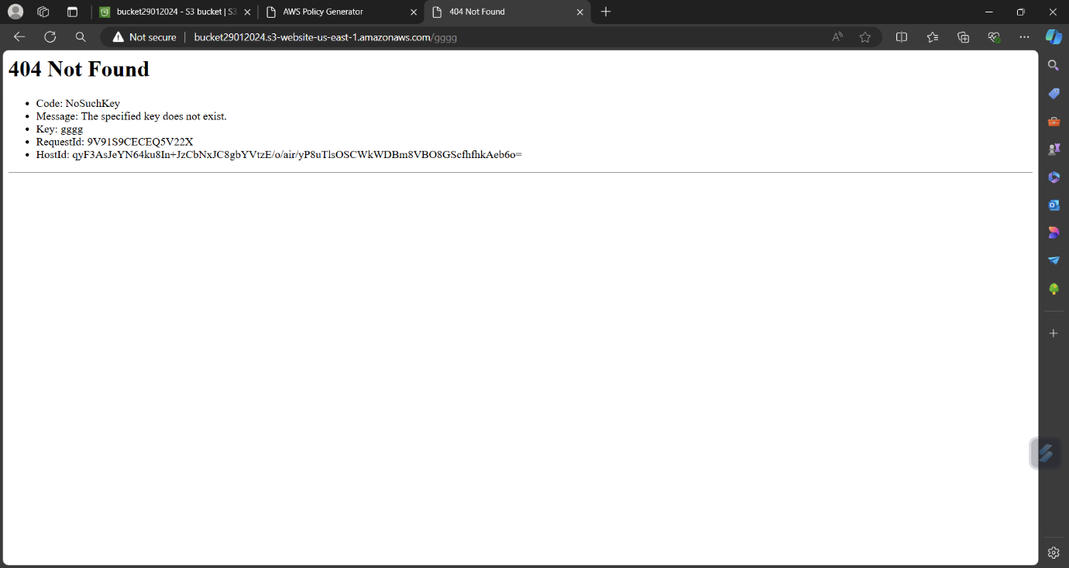

2. Add a lifecycle rule for the bucket:

a. Transition from Standard to Standard-IA in 60 days

b. Expiration in 200 days

Create the rule:

Name your rule (e.g., "Transition and Expiration Rule").

Scope the rule to apply to the entire bucket or a specific prefix/tag.

Click "Next".

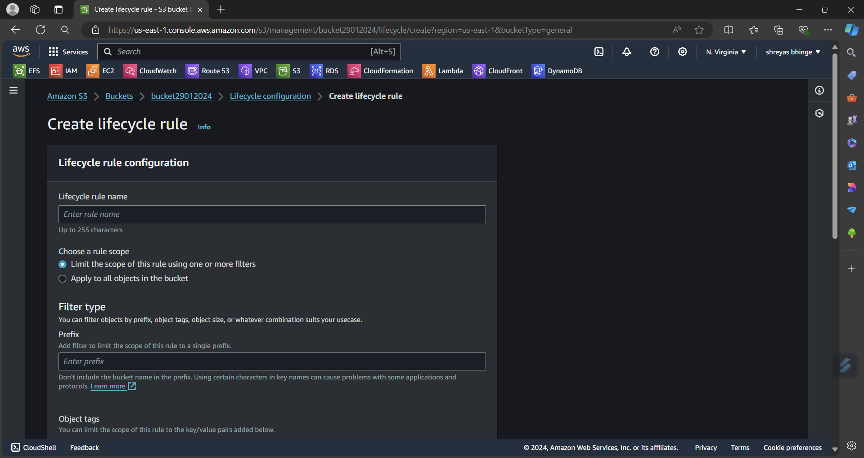

Configure Transition actions:

* Under "Storage class transition", click on "Add transition".
* Set the "Current version" to transition from "Standard" to "Standard-IA".
* Specify the transition after 60 days.
* Click "Next".
* Configure Expiration actions:
* Under "Expiration", set the expiration for "Current version" to 200 days.
* Click "Next"

Review and create the rule:

Review your settings and click "Create rule".

